**Lab Task 10**

**Numerical Computing Lab(105127)**

**Ali Afzal(63961)**

Q1:

Code:

import numpy as np

from numpy import array, arange, zeros

A = array([[1,3,-2],[3,5,6],[2,4,3]])

B = array([[5],[7],[8]])

n,n = A.shape

def LUD(matrix):

row, col = np.shape(matrix)

L = zeros((row, col))

U = zeros((row, col))

if row != col:

return []

for i in range(col):

for j in range(i):

suma = 0

for k in range(j):

suma += L[i][k] * U[k][j]

L[i][j] = (matrix[i][j] - suma) / U[j][j]

L[i][i] = 1

for j in range(i, col):

sumb = 0

for k in range(i):

sumb += L[i][k] * U[k][j]

U[i][j] = matrix[i][j] - sumb

return L, U

L, U = LUD(A)

print("Lower Matrix:")

print(L)

print("___________________________________________")

print("\n")

print("Upper Matrix:")

print(U)

y = np.zeros_like(B)

print("___________________________________________")

print("\n")

print("After Forward Substitution: ")

for i in range(len(B)):

temp = np.dot(L[i, :i], y[:i])

y[i] = B[i] - temp

print ('\n y%i = %f \n'%(i+1,y[i,0]))

x = np.zeros_like(y)

for i in range(len(x), 0, -1):

x[i-1] = (y[i-1] - np.dot(U[i-1, i:], x[i:])) / U[i-1, i-1]

print("___________________________________________")

print("\n")

print("Resultant A : \n",A)

print("___________________________________________")

print("\n")

print("After Backward Substitution: ")

print("Value of x1 = ", x[0])

print("Value of x1 = ", x[1])

print("Value of x1 = ", x[2])

print("___________________________________________")

print("\n")

print("Inverse of A : ")

print(np.linalg.inv(A))

Output:

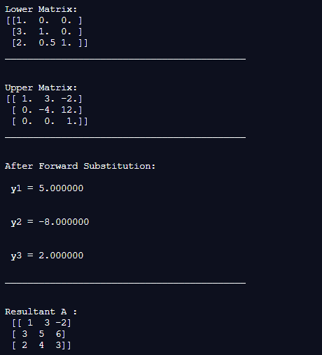

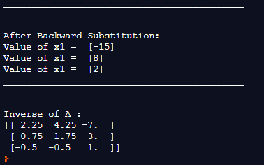

Q2:

|  |  |  |
| --- | --- | --- |
| S# | Functions | Root |
| 1 | 83x+11y-4z=95  7x+52y+13z=104  3x+8y+29z=71 | X1=5.2871  X2=-11.980  X3=52.9489 |
| 2 | 8x-3y+2z=45  4x+11y-z=71  6x+3y+12z=35 | X1=10.5148  X2=1.125  X3=-18 |
| 3 | x + 3y - 2z=5  3x +5y +6z=7  2x +4y +3z=8 | x1=-15  x2=8  x3=2 |